WordCount with MapReduce and Hadoop

Khai Nguyen

khainguyen@temple.edu

CIS 4517 Data Intensive and Cloud Computing

**Problem 1 & 2: Word Count**

To produce Project > Export > JAR File > *Next*

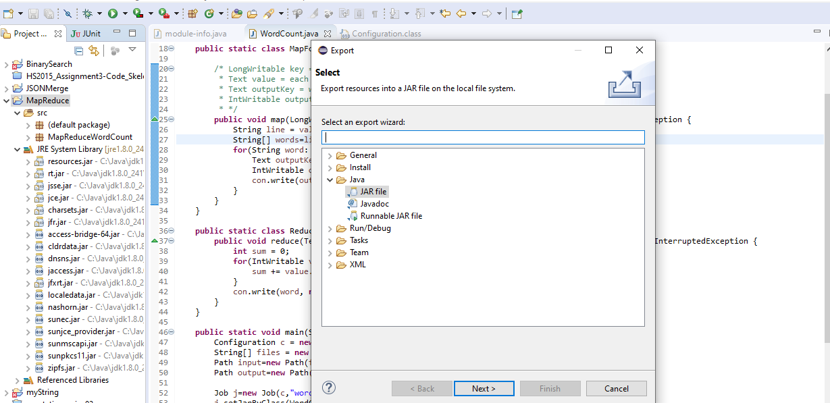

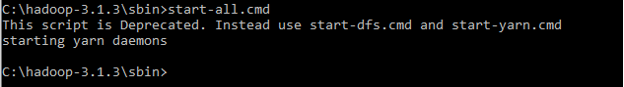

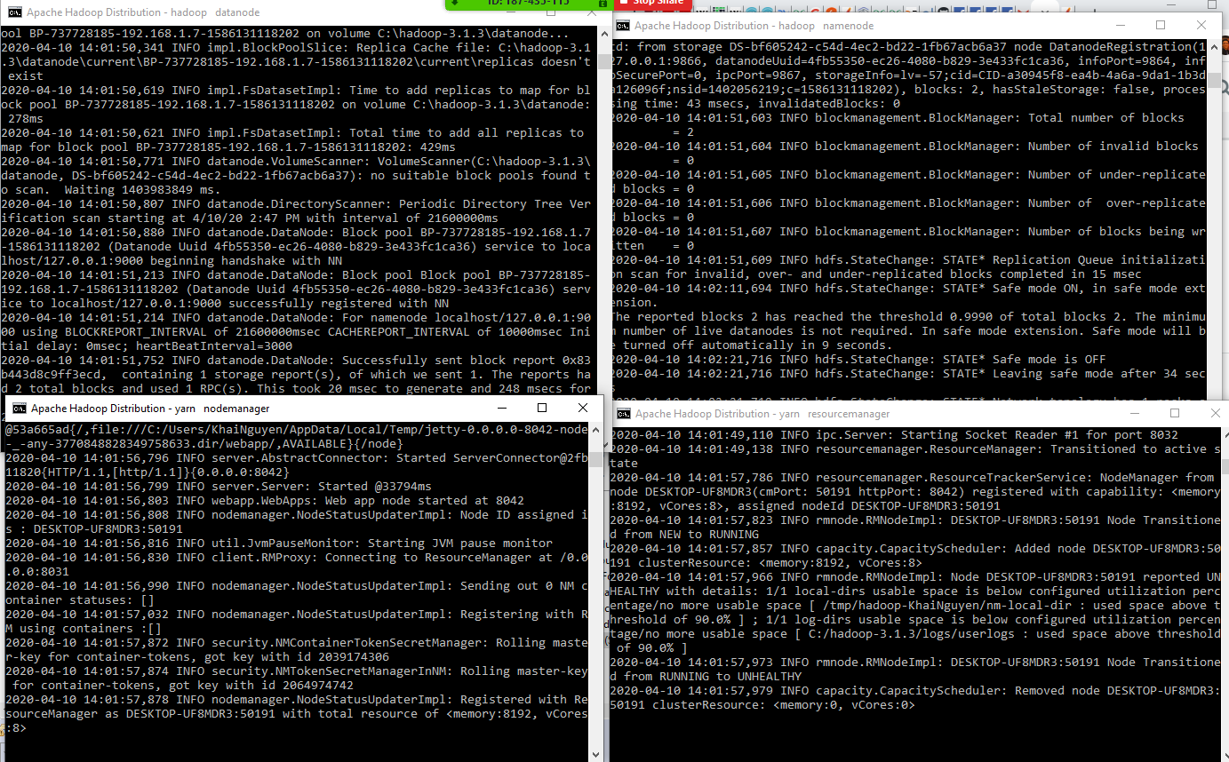

* Upload file to HDFS, store in /testKhaiNguyen

C:\Users\KhaiNguyen\Documents\CS_4517\Project\Project_4\MapReduce_Project>hadoop fs -put Pride_and_Prejudice.txt /testKhaiNguyen



* Check if file is upload by viewing content

C:\Users\KhaiNguyen\Documents\CS_4517\Project\Project_4\MapReduce_Project>hadoop fs -cat /testKhaiNguyen/Pride_and_Prejudice.txt



* Run MapReduce

C:\Users\KhaiNguyen\Documents\CS_4517\Project\Project_4\MapReduce_Project>hadoop jar map_reduce.jar MapReduceWordCount.WordCount /testKhaiNguyen/Pride_and_Prejudice.txt MRDir3

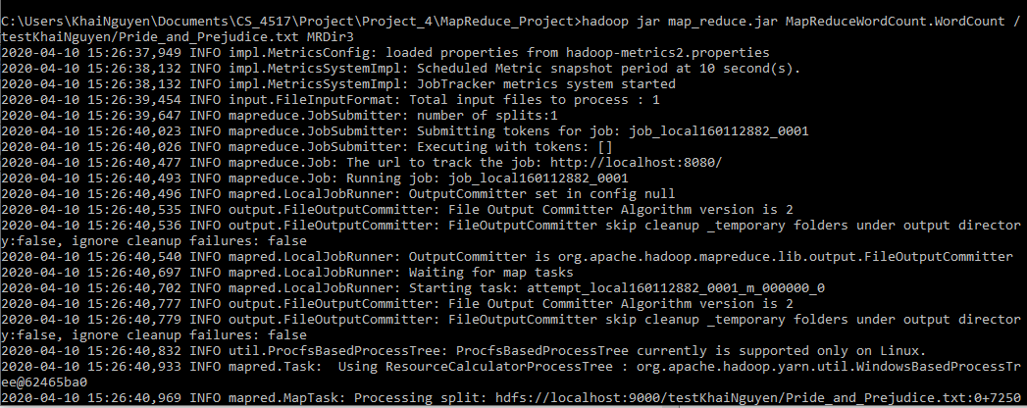

* View files created.

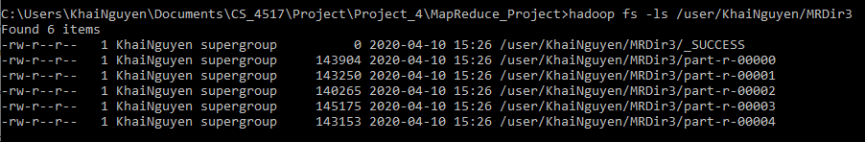

* Download files

hadoop fs -get /user/KhaiNguyen/MRDir3/part-r-* .



* Sort

hadoop fs -cat /user/KhaiNguyen/MRDir3/part-r-* | sort > ./outputFiles/combined.txt



* View number of words OR number of lines since each line is designated for 1 word

find /c /v "" "./outputFiles/combined.txt"

Problem 1:



Problem 2:



* Display last 5 lines.

Problem 1:

Since there are 6738 lines, we can display the rest of the files starting at line 6733 to get the last 5 lines.

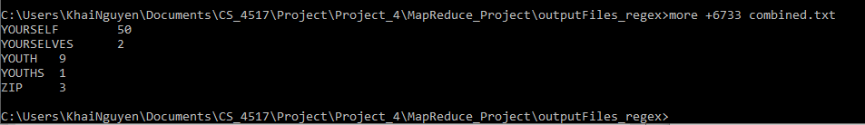

Problem 2:

Since there are 6582 lines, we can display the rest of the files starting at line 6577 to get the last 5 lines.

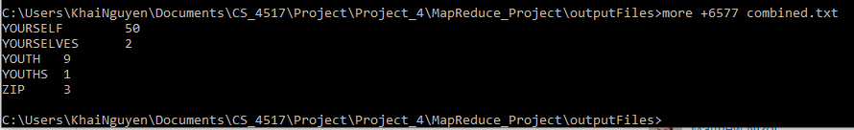

* Display first line

more combined.txt

Problem 1:

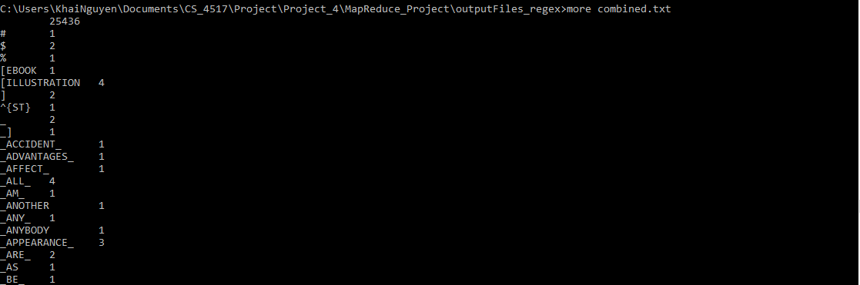

Problem 2:

